Assignment 10.
- What is view and its types?
- A View is a virtual table that displays data from one or more database tables based on the defined relationship and selection conditions
- A View does not store physical data, it only shows data that already exist in the database tables.
- Views are mainly used to simplify data access, combine data, and improve readability.
- The view does not store data on its own. It only fetches data from the base table(s) and displays it in a required format.

- Types of View:
1.Database View
2.Projection View
3.Maintenance View
4.Help View

1.Database View:
- A database table joins two or more tables using inner joins and is created at the database level.
- It is mainly used for performance-efficient data retrieval and supports Open SQL SELECT statements.
2.Projection View:
- A projection view is based on only one table and displays selected fields of that table.
- It is used when all fields of a table are not required.
3.Maintenance View: Refer
- A maintenance view allows insert, update, and delete operations on data from multiple related tables.
- It is mainly used for customizing and configuration data maintenance through SM30.
4.Help View:
- A help view is used only for Search Help(F4 help).
- It combines multiple tables to provide meaningful input help for users.

- (A view is a virtual table that displays data from one or more tables, and its types database view, projection view, maintenance view, and help view)

- Create Projection view.
- A projection view is based on only one table and displays selected fields of that table.
- It is used when all fields of a table are not required.

- Go to TCODE- SE11, Select the View Radio button and provide the view name and then click on the Create button.
- 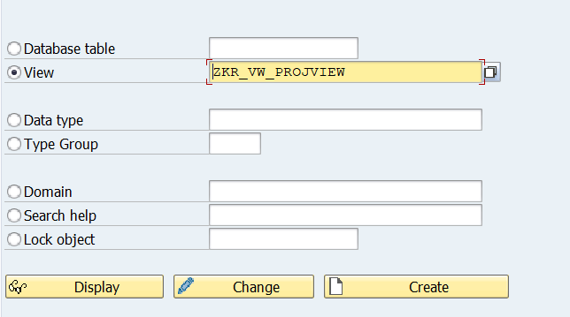

- Select the projection View Radio button and click on Copy Button.
- 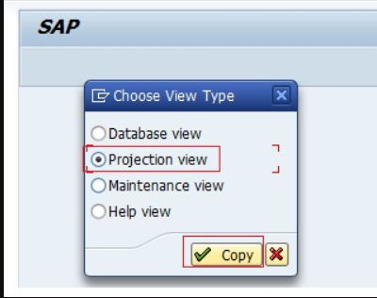
- Provide the Short Description.
- Provide the Basis table ‘ZTable_name’(ZKR_DT_STUDENT) on which we are going to create the Projection view.
- At last Click on the Table Fields Button.
- 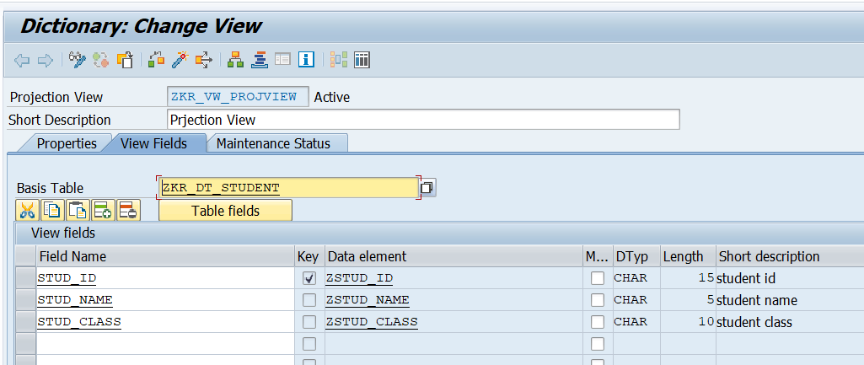

- Select all the necessary fields from the table that we want in our projection view and then click on Copy button. Activate the Projection view and click on the Display Contents Button.
- 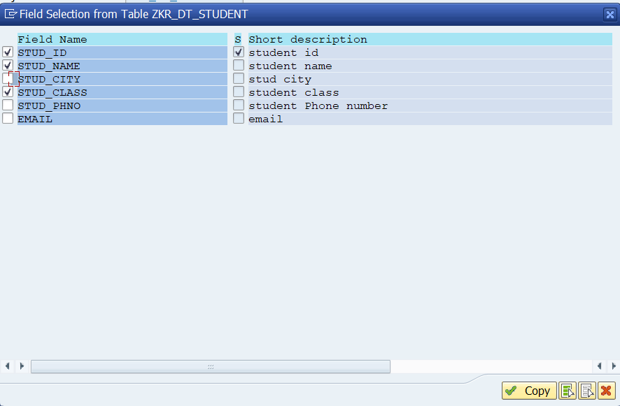
- Execute and Display all the record.

- What is basis table?
- A basis table is the original database table on which a view is created.
Or
- A basis table is the original database table from which a view gets its data.
• Table → stores actual data
• View → shows data taken from table(s)
• Basis table → the table from which the view gets its data

- Example:
- If you have a table STUDENT with fields:
- STUD_ID, NAME, DEPT, AGE
- And you create a view that shows only:
- STUD_ID, NAME
- Here, STUDENT is the base table, and the view only displays selected fields from it.

- Is foreign key mandatory to create database table?
- No.
- A foreign key is NOT mandatory to create a database table or a view in SAP.
- We can create a view without foreign keys.
- A view does not require foreign keys to be created.
- Views only read data from base tables and do not enforce relationships.

- Create DataBase View
- A database table joins two or more tables using inner joins.
- Go to TCODE-SE11, Select the view button and Provide the view name
- 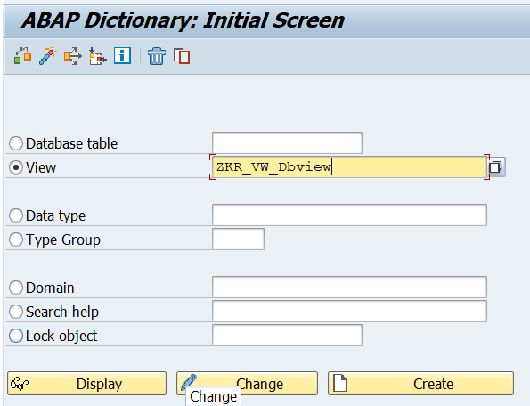
- Select the Database View button and click on the Copy button.
- 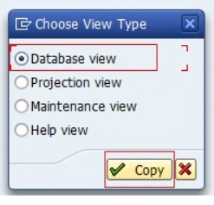
- Provide the Short Description and click on the Table/Join Conditions Tab
- In the Tables Section provide the table name as ‘ZTable_Name’(ZKR_DT_EMP)and click on the Relationships Button.
- First provide the Foreign key table or the dependent table name

- 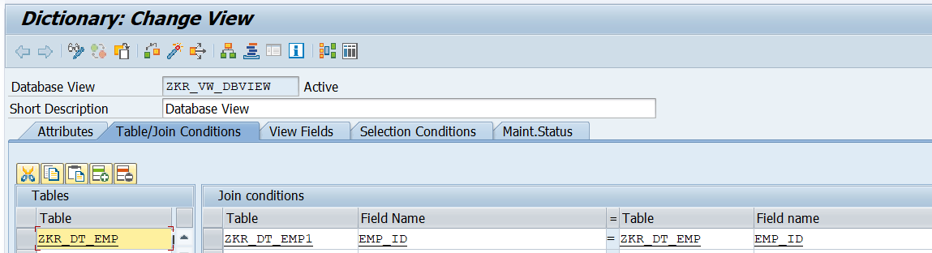

- Click on the View Fields Tab and then click on the Table Fields button.
- Select the ZKR_DT_EMP table and click on the CHOOSE button.
- 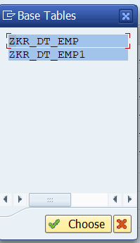

- Select the fields of the table to include them in the data base view and click on Copy Button.
- 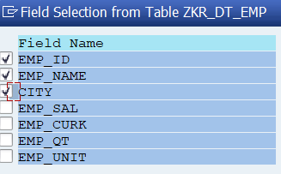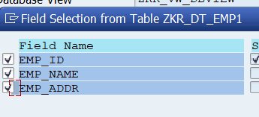
- Join Conditions are automatically filled based on the two table .
- 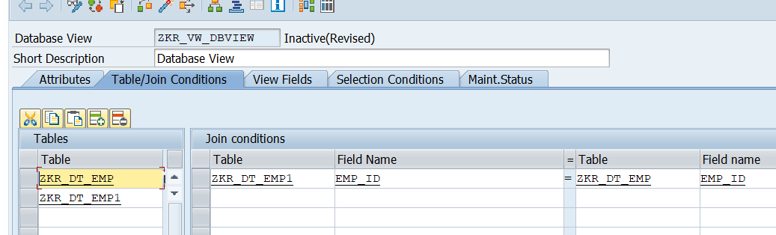

- then click on the active button and then click on the Display contents button.
- 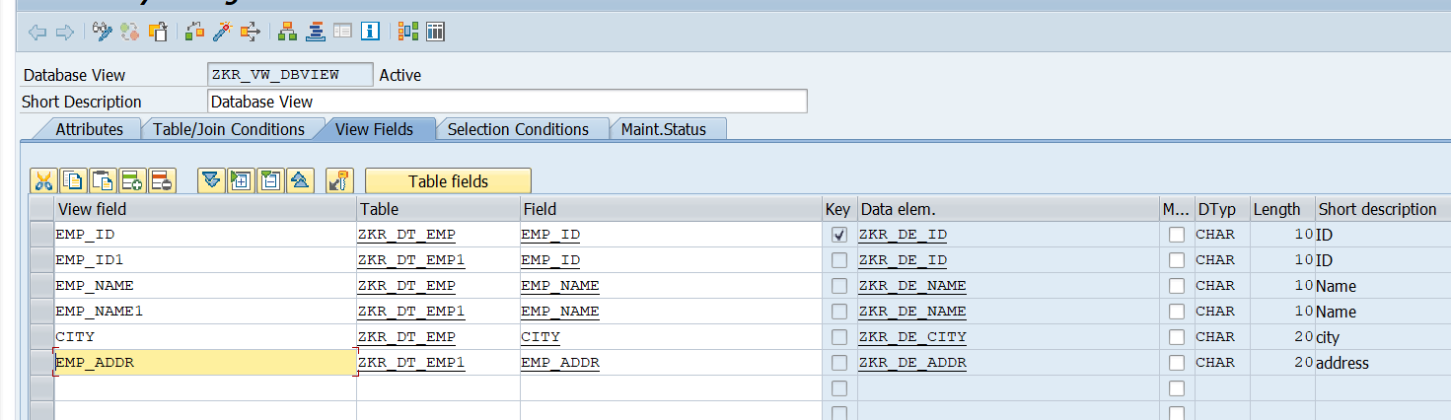

- Now Click on the Execute button
- 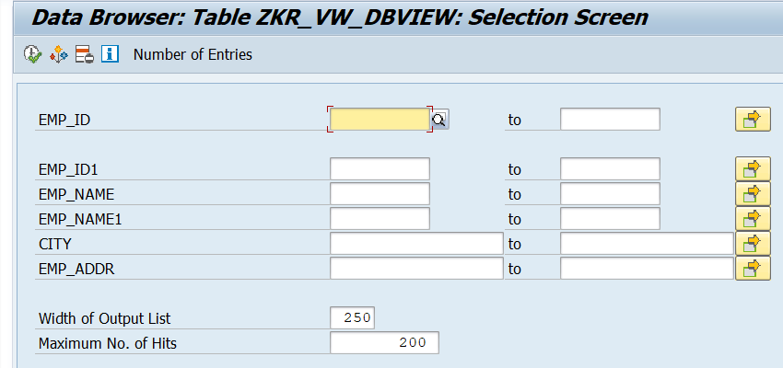
- The data base view shows values from two different tables.
- 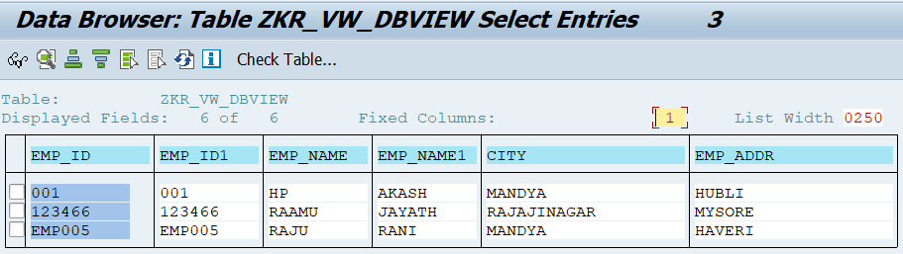

- Create Database View for single table
- A database view for a single table is created in SE11 by selecting Database View and choosing Single basis table with required fields.

- In the Tables section, enter the single base table name.
- Move the required fields from the table to the view fields.
- In the Tables section, enter the single base table name.
- 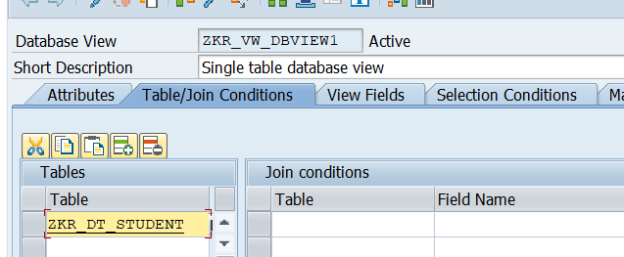

- Move the required fields from the table to the view fields.
- 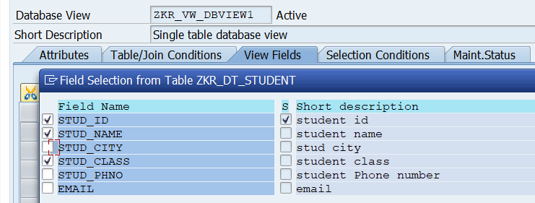

- Save the view in a package or as a local object.
- Click Activate to activate the database view.
- View the contents of the single table
- 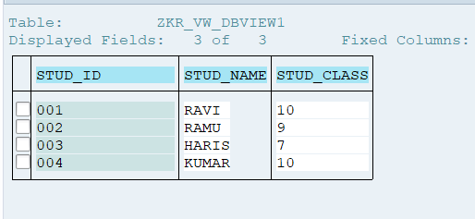

- Create help view for 2 table.
- Goto SE11
- Select View and enter a view name,create
- Choose Help View and click Continue.
- 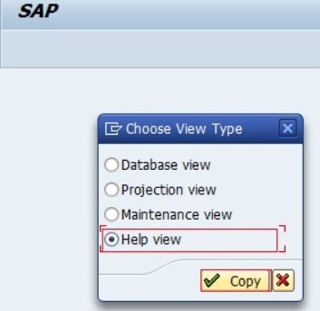
- Provide the short text and in the Tables Section Provide the table Name ‘Table_Name’(ZKR_VW_HELPVIEW) and then click on the Relationships Button.
- 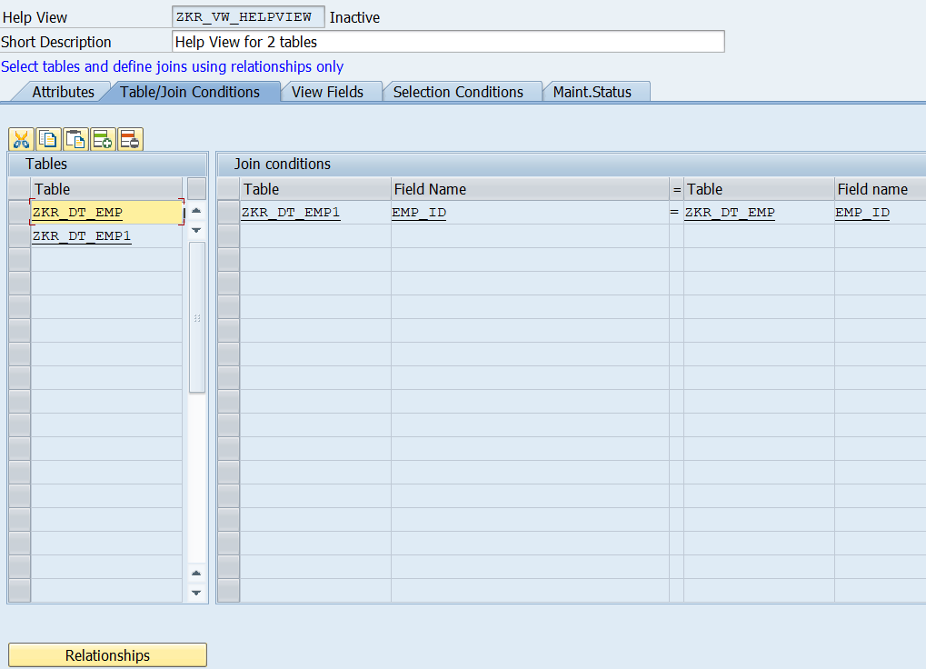

- Select the Table and Appropriate fields and then click on the Copy Button.
- 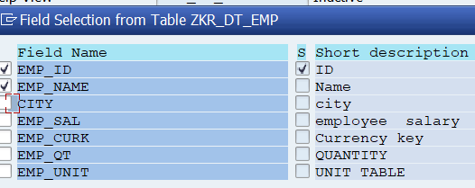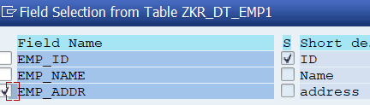

- As per the fields selected from two tables, the Help View is populated with fields from two tables and at last Activate the Help View
- 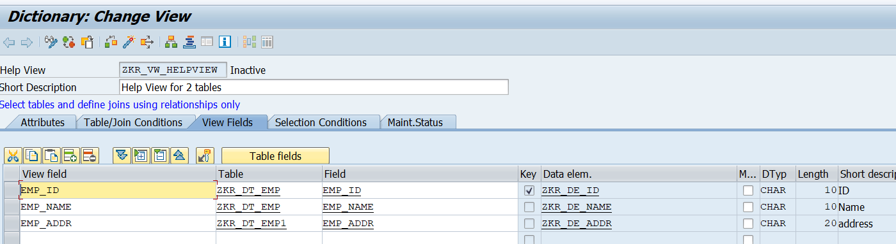

- What are the uses of maintenance status? Refer
- Maintenance status defines how a table or view can be maintained, that is, whether users can display, insert, change, or delete data using standard SAP maintenance tools.

- It controls:
- Whether data entry is allowed or not
- What kind of access (read-only or editable) is permitted
- Whether a Table Maintenance Generator (TMG) can be created

- Read only : Data can only be read through the view.
- Read, change, delete, insert : Data of the tables contained in the view can be changed, deleted, and inserted through the view.
- 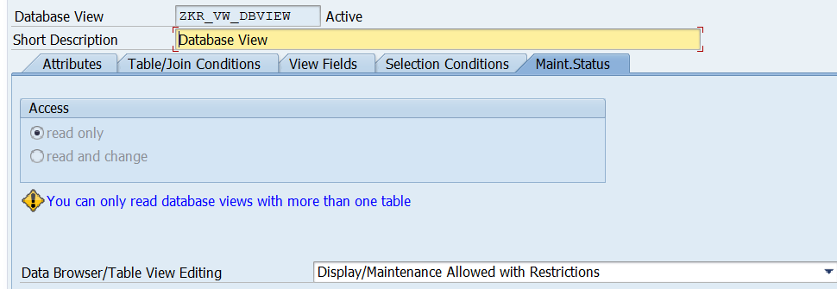

- Why do we need a database view for a single table when a projection view already exists?
- Because a Database View allows more control.
- Projection View
- Used only to select some fields from one table
- No join
- No selection condition
- Mainly for field restriction
- Database View
- Can be used for one or multiple tables
- Supports selection conditions
- Can support joins
- More flexible

- Difference between Database view, Projection view, Maintenance view & Help view.
Database View | Projection View | Maintenance View | Help View
One or more tables | Single table | Multiple tables | Multiple tables
Inner join | No join | Outer join | Outer join
Read and Change | Read only | Read,Update,  delete,Maintain | Read only
 | No cardinality | 1:1 or 1:N | 1:N

